**Experiment No.06**

**PART A**

(PART A : TO BE REFFERED BY STUDENTS)

**A.1—Aim:**

**Study and Implementation of shortest path routing algorithm (Static)**

**A.2--- Prerequisite:**

Routing Algorithms , Graphs

**A.3--- Outcome:**

After successful completion of this experiment students will be able to:

1. Understand how routing algorithm works.
2. Implement Shortest path routing algorithm.

**A.4--- Procedure:**

**Task:**

1. To connect client to server

2. See the simulation of sent and received packet using general and complex PDU

3. Check the OSI layers of the packet

*4.* Observe the output and complete PART B of lab manual

5. Save and close the file and name it as **EXP 6_ your Roll no.**

**(PART - B)**

(TO BE COMPLETED BY STUDENTS)

(Students must submit the soft copy as per following segments within two hours of the practical. The soft copy must be uploaded on the Blackboard or emailed to the concerned lab in charge faculties at the end of the practical in case there is no Black board access available)

|  |  |
| --- | --- |
| Roll. No. A016 | Name: Varun Mahendra Khadayate |
| Class B.Tech CsBs | Batch: 1 |
| Date of Experiment: 26-02-2022 | Date of Submission:27-03-2022 |

**B.1: Procedure of performed experiment**

(Students are expected to write the procedure of performed experiment)

1. In Cisco Packet Tracer, create a connection in Logical Mode.

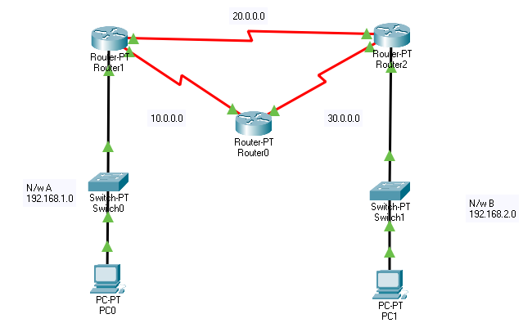

1. Add IPv4 for PC1 as 192.168.1.2 and Default Gateway for PC0 as 192.168.1.1 also do the same for PC01 with IPv4 as 192.168.2.2 and Default Gateway as 192.168.2.1

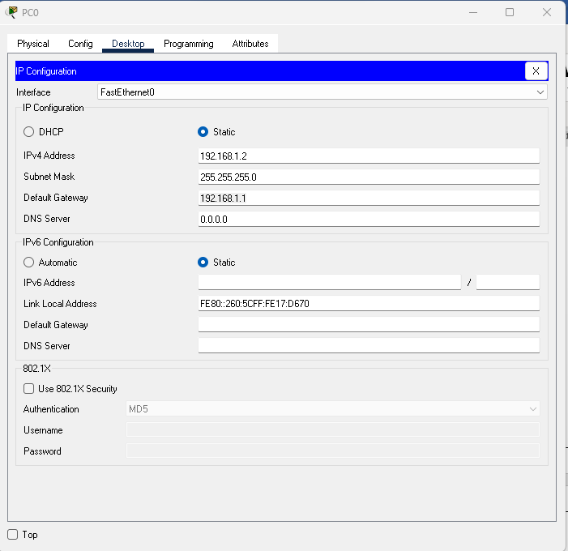 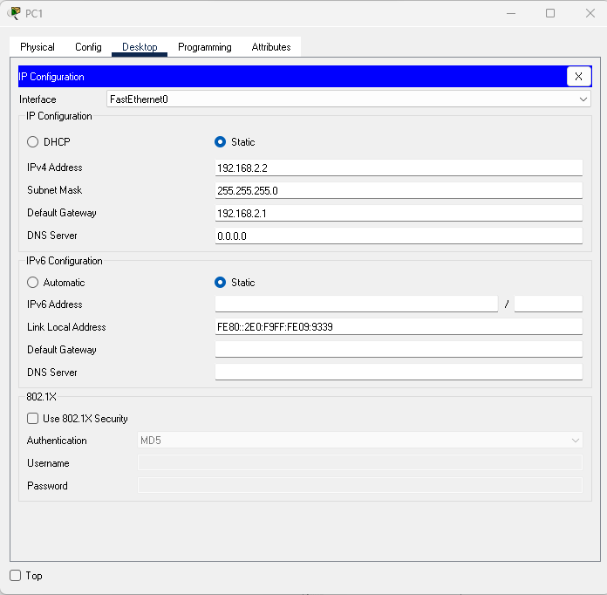

1. In Router1 for FastEthernet0/0 add IPv4 address as 192.168.1.1 and click on ON, for Serial2/0 add IPv4 address as 10.0.0.1 with clock at 64000 and click on ON, for Serial3/0 add IPv4 address as 20.0.0.1 with clock at 64000 and click on ON

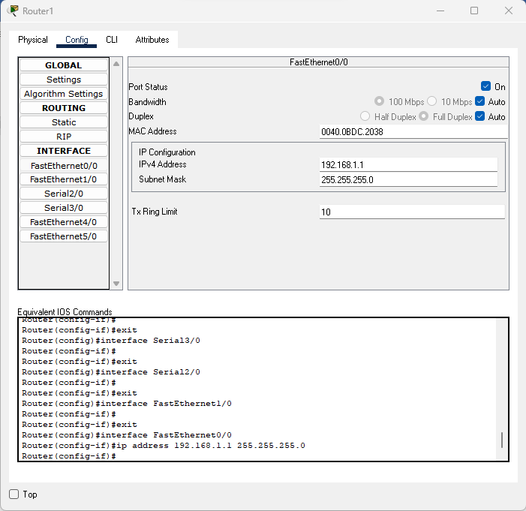 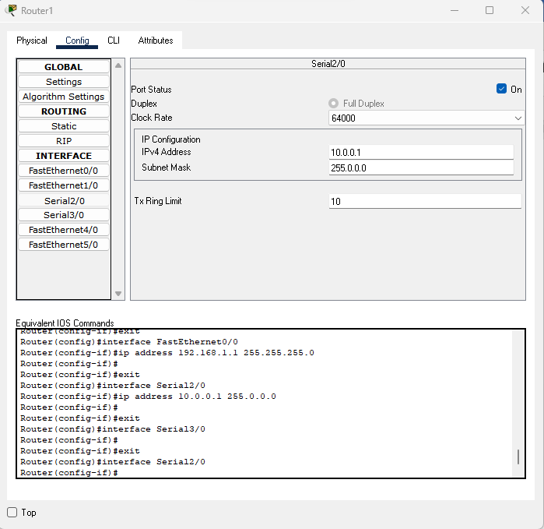 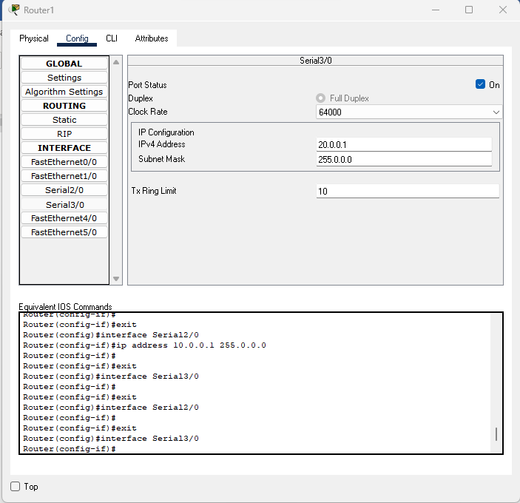

1. Rin the below commands in CLI for Router0

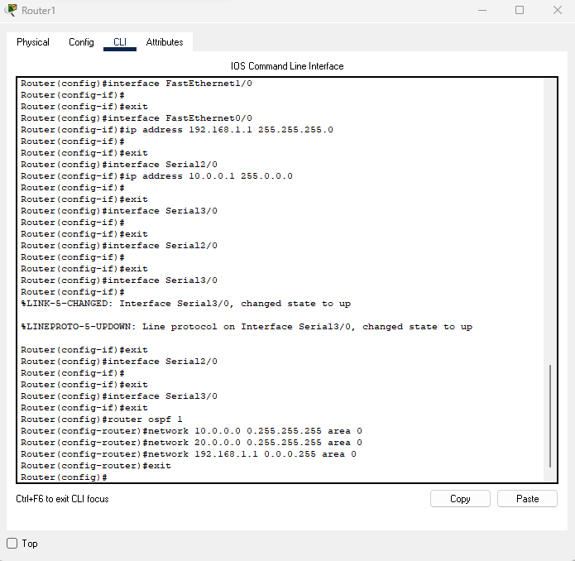

1. Run the Simulation with only ICMP and OSPF working

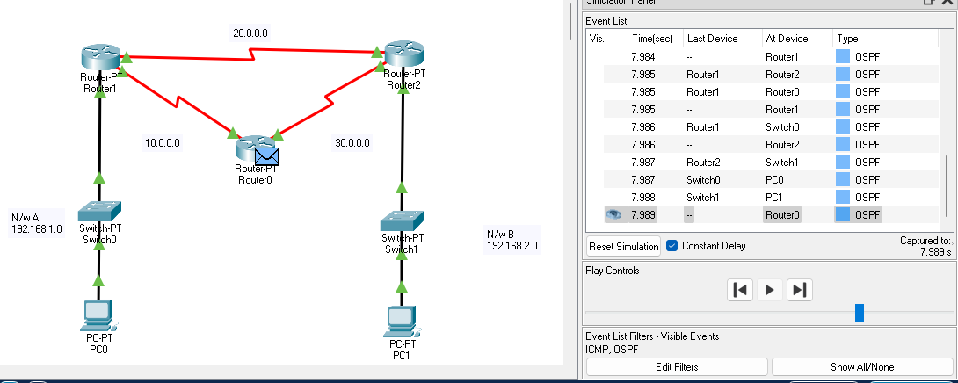

**B.2: Observations and Learning’s:**

(Students are expected to comment on the output obtained with clear observations and learning for each task/ sub part assigned)

All the Task were able to be completed and the Simulation was a Success, the Output received was the desired one.

**B.3: Conclusion:**

(Students must write the conclusion as per the attainment of individual outcome listed above and learning/observation noted in section B.2)

Hence, we were able to Study and Implementation of shortest path routing algorithm (Static)